Documented Debugging + Flowchart(s)
CSD-325 Module 2
Kao Yang
CSD-325 Advanced Python
Module 2 Assignment

Program Overview
For this assignment, I used a Python item total calculator. The program asks the user for an item price and quantity, sends those values to the calculate_total() function, and displays the calculated total. I selected this program because the function call makes it easy to demonstrate a breakpoint, Step Into, and variable inspection during debugging.
Program file | main.py
Function | calculate_total(price, quantity)
Test price | $12.50
Test quantity | 3
Expected result | $37.50

Final Python Program
# Kao Yang
# CSD-325
# Module 2 - Documented Debugging + Flowchart
def calculate_total(price, quantity):
total = price * quantity
return total
def main():
print("Item Total Calculator")
price = float(input("Enter the price of the item: $"))
quantity = int(input("Enter the quantity: "))
total = calculate_total(price, quantity)
print(f"Your total is: ${total:.2f}")
if __name__ == "__main__":
main()

Program Flowchart
The flowchart models the sequence of the program, including the function call and returned total.
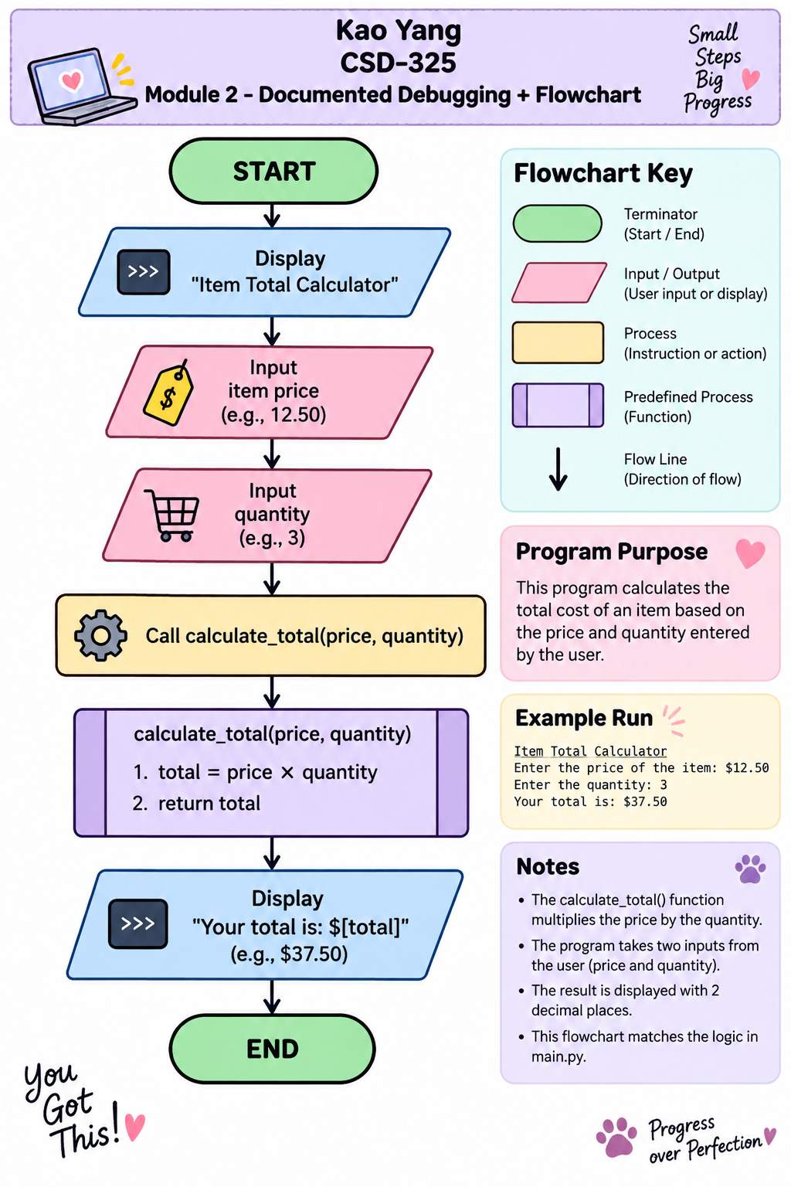
Figure 1. Flowchart for the item total calculator program.

Documented Debugging
I used Python’s built-in debugger (pdb) in Replit. I temporarily added breakpoint() before the function call so I could stop the program, step into the function, and inspect the calculated value.

Screenshot 1: Breakpoint Reached
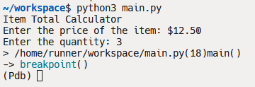
Figure 2. The program stopped at the breakpoint and entered pdb debugging mode.
After entering a price of $12.50 and a quantity of 3, the program stopped at the breakpoint. The (Pdb) prompt confirmed that the debugger was active and that I could control execution one step at a time.

Screenshot 2: Step Into the Function
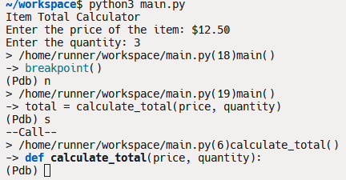
Figure 3. Using the s command stepped into calculate_total(price, quantity).
I first used n to move from the breakpoint to the function call. I then used s (Step Into). The debugger moved into calculate_total(), showing that execution had entered the function rather than running past it.

Screenshot 3: Step Through and Inspect the Result
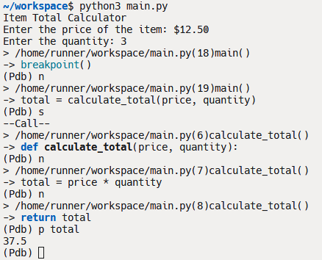
Figure 4. The debugger stepped through the calculation and printed the value of total as 37.5.
Inside the function, I used n (Next) to execute the multiplication and move to the return statement. I then entered p total to inspect the variable. The debugger displayed 37.5, which matched the expected result for 12.50 × 3. Afterward, I used c (Continue) to allow the program to finish.

Reflection
This debugging exercise helped me see the difference between simply running a program and examining what happens while it runs. The breakpoint let me stop the program at a specific location, while Step Into showed how execution moved from main() into calculate_total(). Inspecting total also confirmed that the function produced the correct value before returning it. I can see how these tools would be useful in a larger program because they make it easier to locate where an unexpected value or error begins instead of guessing from the final output.

